MD2201: Data Science

Name of the student: Bhagwat Vinod Kolekar Roll No. 58

Div: ET-B Batch: B3

Date of performance:

Experiment No.3

Title: Hypothesis Testing
Aim: i. To perform hypothesis testing for single sided tail.
ii. To perform hypothesis testing for Two-sided tail.

Software used: Programming language R.

Code Statement:
- Suppose the manufacturer claims that the mean lifetime of a ball bearing is 10000hours. The auditing team stated that the mean lifetime is less than what is claimed. On the basis of a randomly chosen sample of 50 ball bearings as given in the dataset, at 0.05 significance level, can we reject the claim of the manufacturer? What will be your interpretation if the significance level is made as 0.01? Consider the data set titled “Hypothesis_csv1.csv”.

- The nutrition label on a bag of potato chips says that a one ounce (28 gram) serving of potato chips has 130 calories and contains ten grams of fat, with three grams of saturated fat. A random sample of 35 bags yielded a sample mean of 134 calories with a standard deviation of 17 calories. Is there evidence that the nutrition label does not provide an accurate measure of calories in the bags of potato chips? We have verified the independence, sample size, and skew conditions are satisfied. Take alpha as 5% and 1%.

Code: #QUESTION 1 ----

f<-read.csv("Hypothesis_csv1.csv")

#CASE 1(0.05)

m<-mean(f$Life_Hrs)
cat("\nQuestion 1:\n\nmean is :",m)

sd1<-sd(f$Life_Hrs)
cat("\nStandard deviation is :",sd1)

se<-sd1/sqrt(50)
cat("\nstandard error is :",se)

p1<-pnorm(m,10000,se)
cat("\nprobability is :",p1)

if(p1<0.05)
{
cat("\nClaim can be rejected for 0.05")
}else
{
cat("\nClaim cannot be rejected for 0.05")
}

#CASE 2(0.01)

if(p1<0.01)
{
cat("\nClaim can be rejected for 0.01")
}else
{
cat("\nClaim cannot be rejected for 0.01")
}

#QUESTION 2 ----

#cASE 1 (0.05)

se2<-17/sqrt(35)

p2<-pnorm(134,130,se2, lower.tail =F)*2
cat("\n\nQuestion 2:\n\nprobability is :",p2)

if(p2<0.05)
{
cat("\nNull hypothesis can be rejected for 0.05 ")
}else
{
cat("\nNull hypothesis cannot be rejected for 0.05 ")
}

#CASE 2(0.01)

if(p2<0.01)
{
cat("\nNull hypothesis can be rejected for 0.01 ")
}else
{
cat("\nNull hypothesis cannot be rejected for 0.01 ")
}

Results: Display the output obtained on R console for all the cases.

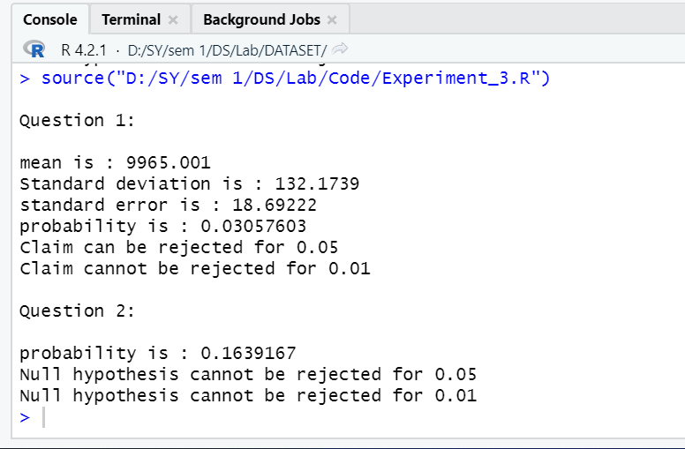

Conclusion: We performed hypothesis testing for single-sided and two-sided tail by finding mean , standard deviation, standard error ,and probability . And we use pnorm function .

And last step is done by using ‘if else loop’. By this we know about hypothesis can be rejected or not.

